Joining the AWS realm
We finished the previous chapter with a fully functional application that we are ready to deploy. This chapter explains how to use Ansible to deploy the sample application we just created into Amazon EC2. The steps describe both how to deploy the application and how to configure the AWS components required to run the application, like RDS or DynamoDB, .
If we recover the sketched project plan we defined at the beginning of the last chapter, we had some steps to follow:
- Setup a development environment, including Amazon AWS services you may use
- Develop the code
- Setup a staging area (development) in Amazon AWS
- Setup a test environment in Amazon AWS
- Setup a production environment in Amazon AWS
- Launch the application
- Scale it as the demand grows
- Profit!
This chapter covers steps 3 and 7. As we mentioned before, steps 3, 4 and 5 follow almost identical steps, which means that this chapter can be used to deploy additional environments as defined by points 4 and 5.
We also cover part of step 1. As it was said at the beginning of last chapter, we moved all the AWS related steps to this chapter. This includes the steps to configure DynamoDB, which you need to run the sample application in a development environment.
In the following page we show how to use Ansible for deployments in the cloud. Then we talk about how to configure Amazon AWS components, including DynamoDB and Amazon RDS (MySQL). We also show how to configure an EC2 instance with our sample application and, only for a production environment, how to configure both Load Balancer and Autoscaling.

Deploy in EC2
The following sections show how to deploy a single instance to create a test environment. The same steps can be applied to create other deployment sets, like a development or a production environment, backed by Amazon AWS services.
Remember that the scripts are available in Github. They can be downloaded and modified as required to help you deploy the sample application in EC2.

Using Ansible for deployment
Ansible is a tool for DevOps that allows you to remotely execute commands in your servers. It provides a modular system in which you can define individual tasks to run according to the server role. Ansible complements the scripts with a thorough API that helps with common operations and a set of plugins for popular components (Amazon AWS, PostgreSQL, etc.). As a note, the Amazon API that Ansible provides, which you can use to interact with AWS components, is not used in this article.
Ansible has minimal requirements; the only piece of software necessary on your machine to launch Ansible is Python 2.6 (or greater) and a few Python modules. This facilitates its deployment in any development or system administration computer. The connection with the servers is established via SSH, a common protocol included by default on all Linux machines..
Ansible uses a series of scripts to define the instructions to run on a given server. The scripts are called Playbooks and they follow the YAML format. Ansible allows you to execute the scripts on several servers at once, in parallel. This means that, in Ansible, you execute a Playbook once and all your servers will process that set of commands, receiving the same configuration.
The aim of the Ansible scripts in this article is to create a custom AMI that can be used by Amazon AWS to enable auto-scaling of our application. This means that the scripts are run against one instance only, but they can be easily modified to run targeting many instances.

Structure of Ansible Folder
The Github repository contains the Ansible scripts we use to deploy the sample application. If you explore the folder you may notice that there is a certain structure in it. The folders and files are organized following Best Practices for Ansible.
Using best practices is not just a recommendation but almost a mandatory requirement. Many Ansible commands (on version 1.2 and onwards) assume some files will be located in the locations recommended by the best practices by default. Following these recommendations will save you time when trying to use these commands, and will keep the Playbooks nicely organized.
If you open the folder with the scripts, you will notice the following contents:
- groups_vars (folder): contains configuration specific to some server groups
- host_vars (folder): contains configuration specific to a particular host
- roles (folder): contains the role Playbooks, modules with reusable functionality
- dbservers.yml: defines the roles to execute when dealing with database servers
- developments.hosts: contains a list of hosts and groups of hosts that belong to a development environment
- production.hosts: contains a list of hosts and groups of hosts that belong to a production environment
- Readme.md: some notes on the contents of the folder
- site.yml: defines the roles to execute when deploying our application
- testing.hosts: contains a list of hosts and groups of hosts that belong to a testing environment
- webservers.yml: defines the roles to execute when dealing with web servers
From this set of files and folders, there are some that demand a more detailed explanation. For example, there are three configuration files which contain IP address of servers (development.hosts, testing.hosts and production.hosts). If you edit one, you will see something like:
1  2  3  4  5 | # Contains the addresses of all EC2 instances used in testing in each region  # Webservers in Ireland region  [ireland-webservers]  ec2-54-216-124-229.eu-west-1.compute.amazonaws.com
Line 4 defines a group. A group contains a list of IP that map to existing hosts (in line 5, an EC2 instance) or other groups.
The purpose of these files is to define the servers on which Ansible executes the Playbooks. By defining some groups, we can refer to a set of servers via the group name in the Playbooks, ensuring that we run the proper commands in each host. Groups also allow us to expand or reduce the number of servers managed by Ansible by adding or removing IP from the list.
By having three files with the same group names in them (but different IP in the groups), we are defining different execution environments that can benefit from the same scripts. When running Ansible we can select which environment we want to target.

In the root folder there are three main Playbooks available. Each one can be executed to set up either all our system (site.yml) or a specific subset of machines (webservers.yml or dbservers.yml). The site.yml Playbook contains just references to the other two Playbooks. In turn, these Playbooks contain a list of roles to run, in order of execution. The roles are the ones doing the real work, while these main Playbooks just list which ones we trigger for each environment. This division makes it very easy to change the commands being executed on each host.
In this example, the database Playbook is provided for completeness purposes. We use Amazon RDS, which makes this script unnecessary as we don't manage the database servers. But if you decide to deploy your own servers with your own database versions, you can use the Playbook to trigger the proper configuration steps.

In the folder's list you may notice two folders that contain specific configuration for the Playbooks, depending on the group or host we are targeting during execution. The group_vars folder has a list of files named as the groups defined in the hosts files (webservers, databases, ireland-weberservers) and a file named all. Files that correspond to a group name apply only to servers in that group while all applies to all the servers receiving Ansible commands.
Each file contains a list of pairs (key: value) which define variables and values. These variables are then used in the Playbooks, replacing each key by its corresponding value. This allows us, for example, to define the version of Play Framework we want to install in each group and to change it later on by editing only one location.

Finally, the roles folder contains the different 'roles'. A role is a set of Playbooks, templates and other files that do a specific task in a server. For example, the 'common' role has a list of commands to secure a Linux server, installing packages like SELinux. This division on roles facilitates reusing tasks across servers, and we can enable or disable specific tasks for a given group at any moment with minimal effort.

Ansible Scripts
A full description of an Ansible script is outside the scope of this document, please refer to the documentation for this. This section provides a quick overview of the basics of a script.
An Ansible script is a YAML file, which is plain text and human readable, that contains a set of commands to execute in the target servers. An example:
1  2  3  4  5  6  7  8  9  10  11 | # Secures an Ubuntu instance.  #  ---  - name: Update APT package cache  action: apt update_cache=yes  - name: Run apt-get upgrade  action: apt upgrade=yes  - name: Install fail2ban  action: apt pkg=fail2ban state=installed

In the sample above line 3 indicates the start of the script. As you can see, we have three actions defined by a name and the action itself. The name is displayed during the execution of the Playbook, allowing us to know which step is being run. The action corresponds to either an Ansible command, using the modules and API provided by the tool, or a raw command executed via SSH.
The steps are run in order. If none of them fail, the script finishes with a status of success. If a step fails and we have not opted to ignore errors in that particular step, then the script will abort and we will be notified of the error. Having errors in one server may not mean that the execution will stop in other servers.
When writing Playbooks, be aware that Ansible is not atomic. That is, if the execution of the Playbook fails in a server Ansible doesn't rollback any step that has been executed in that server. This means that it is recommended to add steps that can be run multiple times or with proper safeguards. The script may fail in the middle of execution and you may need to execute it again on the same server, which results in some steps being run twice.

Amazon AWS components
This section shows how to configure the different Amazon AWS components we need for the application. We explain how to do this through the UI provided by the Amazon Console.
All the steps assume you have an AWS account, you have access to the Console and you are allowed to create components with your account. Management of account security and roles is out of scope for this article and therefore it is not explained.
Be sure to select the region where you want to deploy your components before proceeding, as to avoid issues caused by having components deployed across different regions.

Configure DynamoDB
As mentioned in the previous chapter, we use DynamoDB to store metadata of images and tags retrieved from Flickr. DynamoDB is very useful for this purpose, as metadata is something that may change as the application grows. In DynamoDB we can define a set of tables with no fixed schema and add more “columns” as needed, without having to change any settings in the table.
Using the DynamoDB console we can define the tables that the sample application uses. To create a table, press the Create Table button at the top:
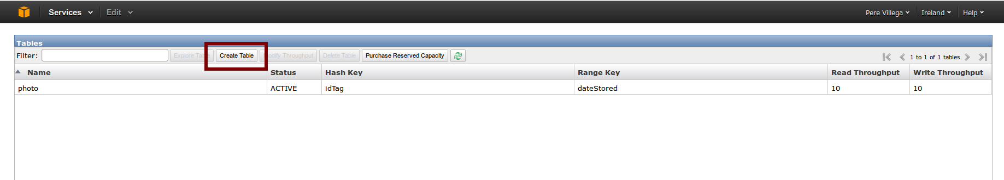
This opens a popup to create a table. In it you can write the name of the table and select the type of key used. DynamoDB uses two kinds of keys, Hash and Hash and Range.
The Hash type is used for elements which can be considered unique. For example, in the sample application a tag is a unique entity, with no duplicate and no dependency to any other element, so a hash key is appropriate.
For the images, which are related to a tag, we use a hash and range key where the hash matches the hash of an existing tag and the range part, a date stored as a string, allows us to differentiate each individual image belonging to a given tag.
First we want to create a table to store the tags, so we type tag as name and select a hash key with name id and type string as the key of the table:
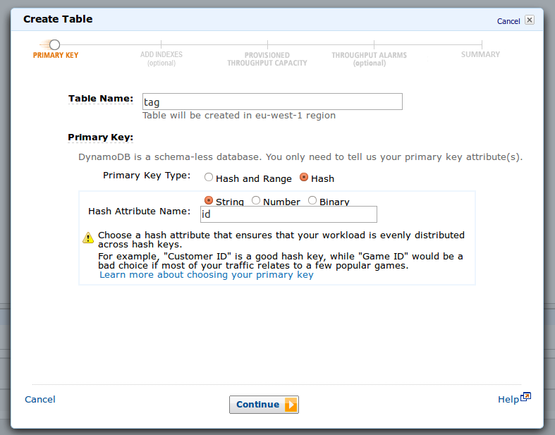
Pressing Continue brings us to the next screen, where you can add additional indexes:
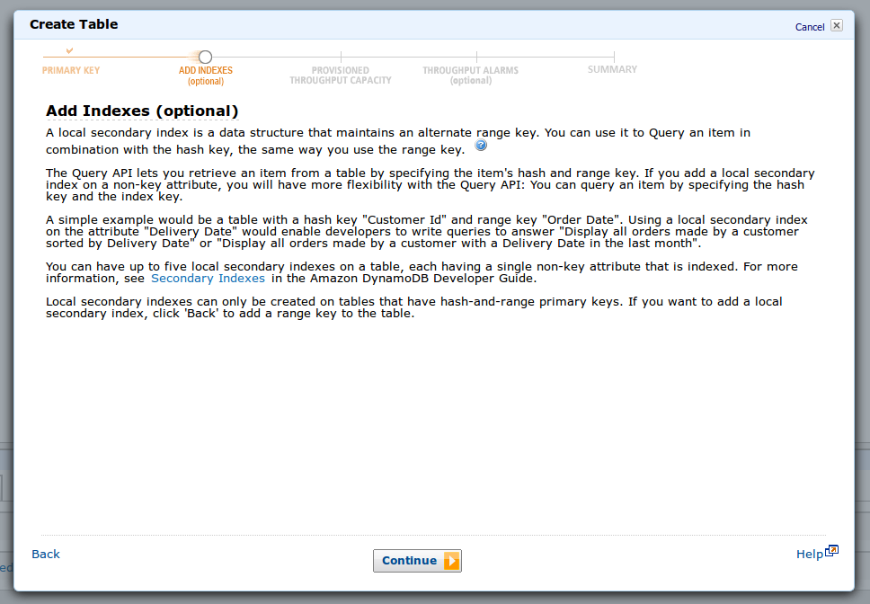
We don't need any, so we press Continue again. The following screen lets us select the Provisioned Capacity. DynamoDB reserves a certain capacity for read and write operations on each table you create:
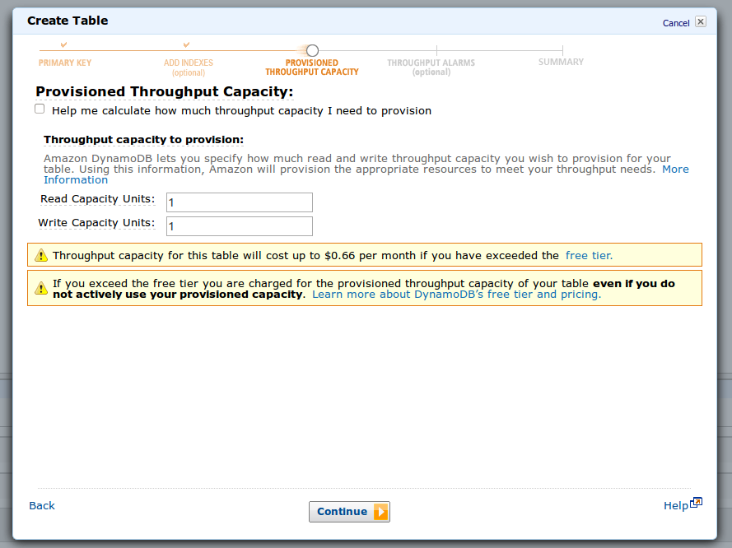
The popup contains links that provide a more detailed description on how does capacity work, but a rough approximation is that each capacity unit is one read or write of a random item per second. Be aware that Amazon bills per capacity reserved, even if it is not used, so try to be conservative in your choice as you can modify it later on if required.
In the next screen we can configure alarms so we are notified if the read or write capacity is over a certain limit, that way the we can act accordingly by increasing the resources allocated for the table:
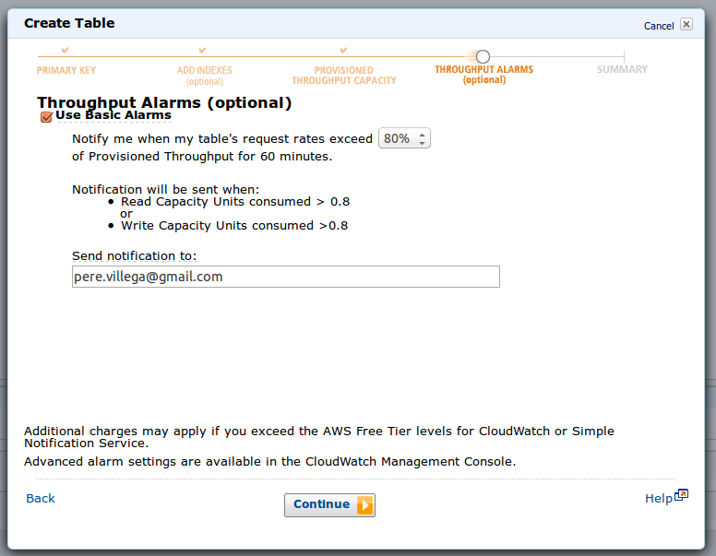
The last screen is a summary of the table configuration, including an estimate of the monthly cost of keeping the table active:

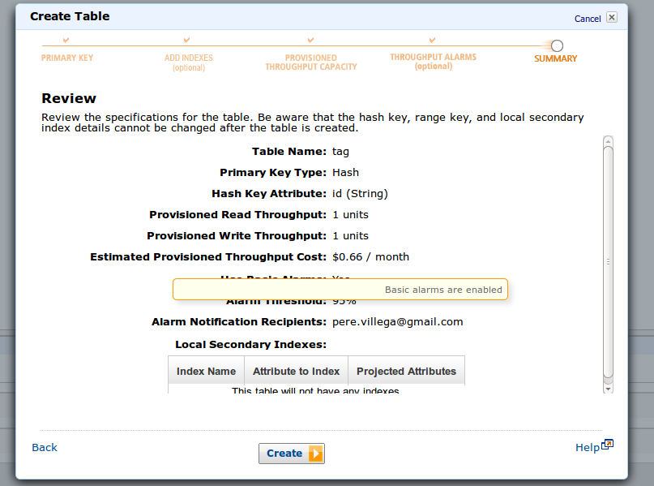
Once the tag table is created, we can add the photos table to DynamoDB. Set a hash and range key in the first screen, as follows:

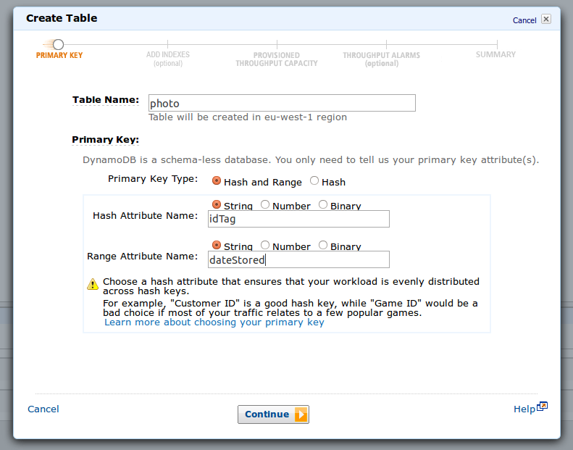
The other screens of the process match the ones seen when creating the tag table.
At this point we have created the tables we need for our application in DynamoDB. You can test them by configuring the Amazon AWS connection details in the sample application, in your development environment, and running the application. After the metadata is loaded from Flickr, you can come back to the console and explore the tables to see the stored data.

Configure Amazon RDS (MySQL)
As mentioned when creating the sample application, we use MySQL to store all the user details generated by Play Authenticate. To deploy our application in Amazon AWS, we need to create a MySQL database in RDS to store the data.
The RDS console allows you to create a MySQL instance that is completely managed by Amazon AWS, including the backups of your data. To start, press the Launch a DB instance button:
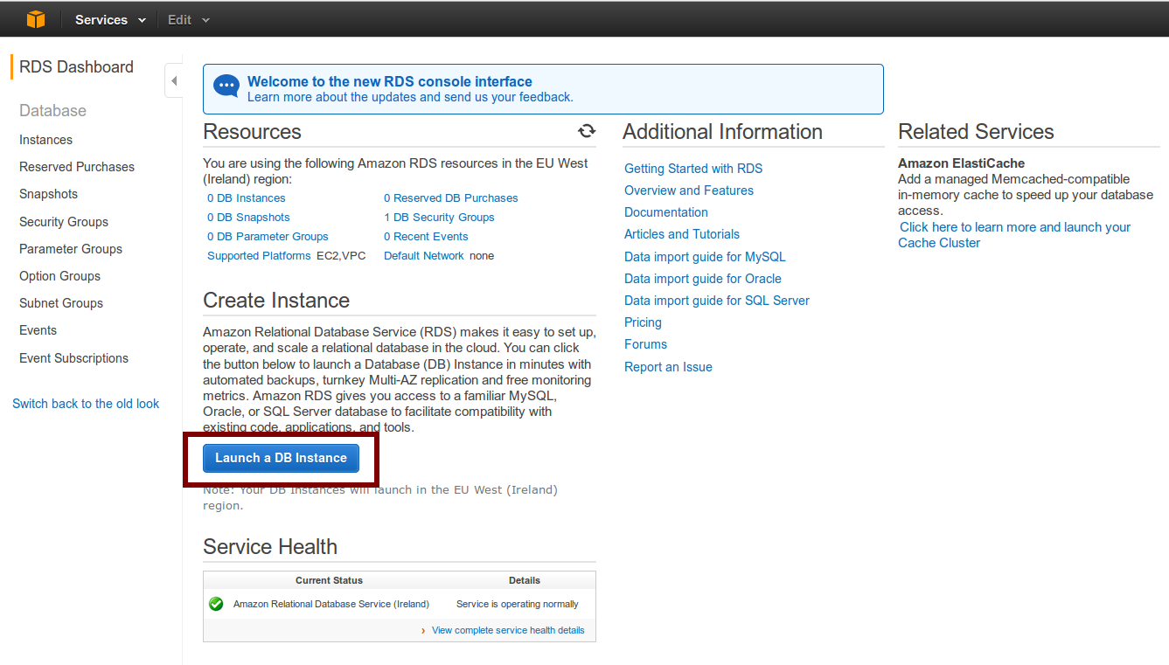
After pressing the button, the wizard to create the database is started. At the first screen, select the database type needed for the application, in this case MySQL:

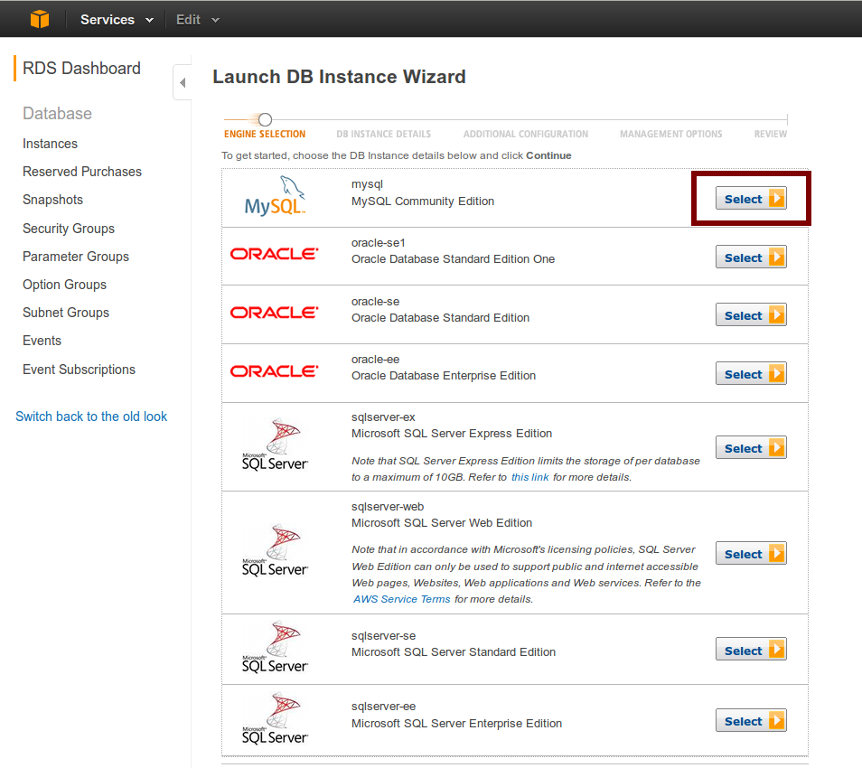
In the next screen we can configure the database:

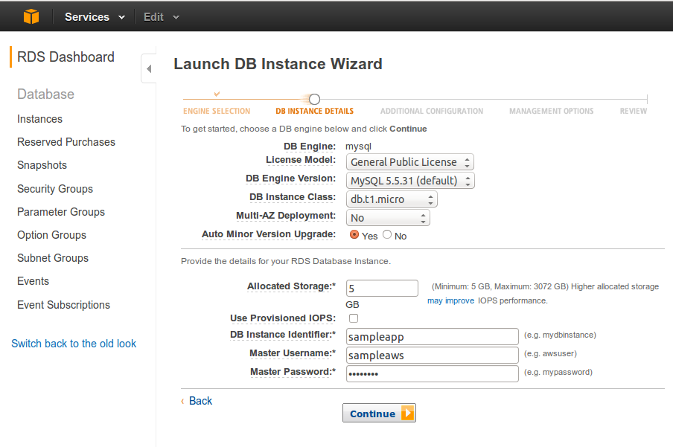
Among the different options available, you can select the version of MySQL to use, the size of the instance and its allocated storage. Remember to write down the identifier, username and password as they are required by the sample application to connect to the instance.
After pressing Continue, the next screen allows us to configure additional details, like the port used to connect to the database:
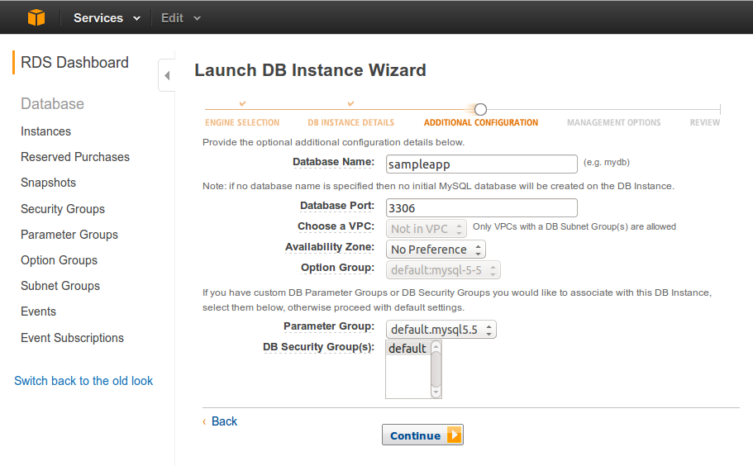
The following screen provides backup configuration, including the time at which we want to create the backups:
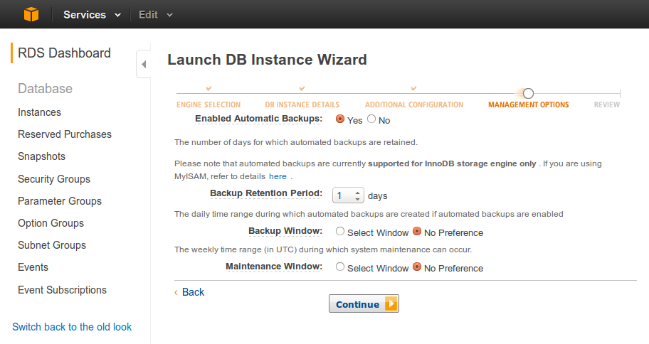
The last screen shows a summary of the configuration for this database instance:
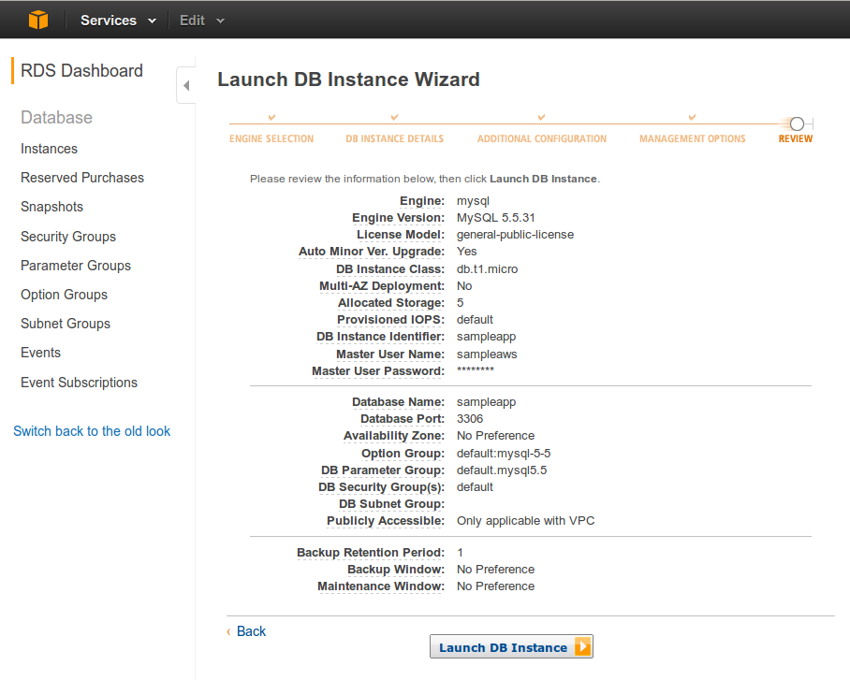
After pressing Launch DB Instance we can see the database being created in the dashboard:
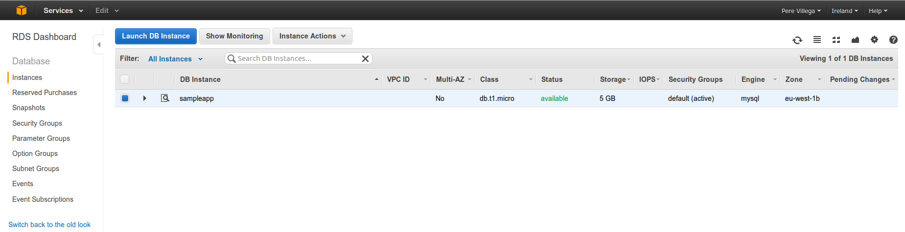
At this stage we have a fully functional MySQL database that we can use to store user details in the sample application.
If you need to scale your RDS instance, Amazon gives you two alternatives. You can resize the instance, using a more powerful box to run the database. Or you can create read-only replicas, which increase the throughput of the database when reading data. Both actions are managed by Amazon, you just need to select to command via the UI and the database settings are modified as requested.

Configure an EC2 instance
This section describes how to create your Amazon EC2 instance. After the instance is running, Ansible is used to configure it (deploying the sample application code) and a custom AMI is created.
Be aware that this section only describes how to create a single instance that is used to generate a custom AMI. These steps can be replicated to create instances for other environments, like a development environment or a production deployment.
Alternatively, once the custom AMI is created you can use it to deploy additional EC2 instances as you need them. Simply select the custom AMI instead of the default Ubuntu one when creating the EC2 instance, and skip the remaining steps.

Create the instance
The Amazon EC2 console allows you to manage your EC2 instances. An EC2 instance is a virtual server managed by Amazon and billed by the hour. Amazon provides several types of instances, with different amounts of RAM and CPU power available for each one.
To create an EC2 instance press the Launch Instance button in the console:
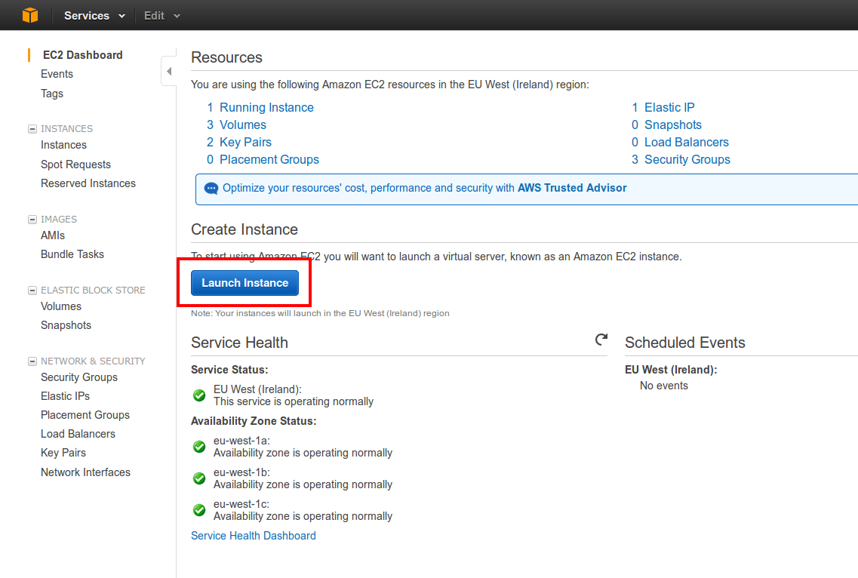
This opens a window in which you can select how to create the instance:
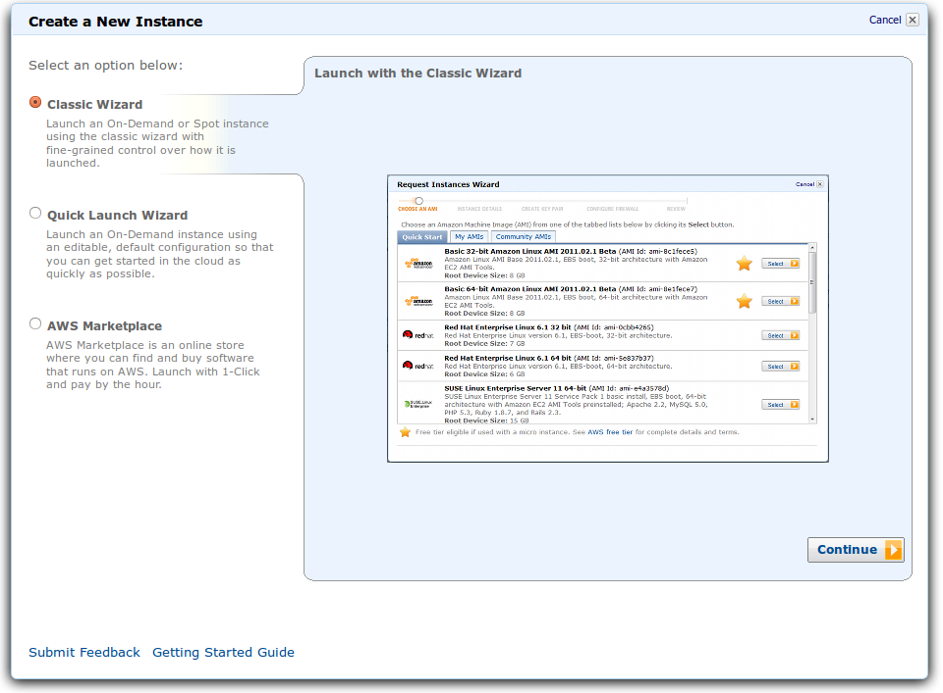
Select Classic Wizard and press Continue. The next screen shows a list of AMI to load as operating system in the server. The default AMI are standalone operating systems, with no additional software installed. We want one of these so we can configure the server as our application needs. In the Quick start tab, select Ubuntu Server 12.04.2 LTS:
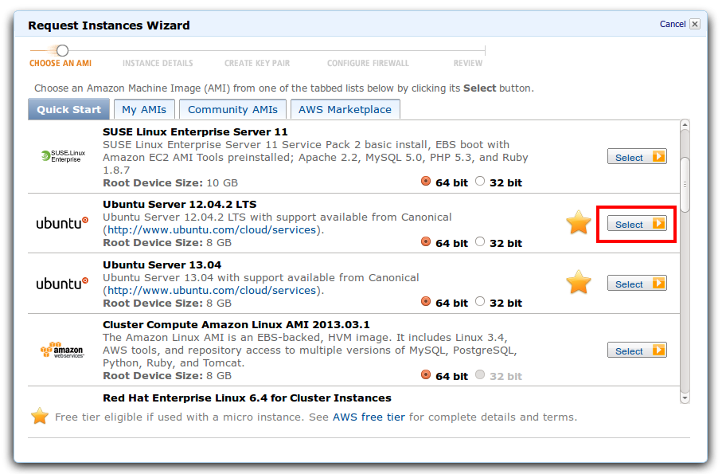
This brings us to a screen where we can select how many instances we want to create and the type of instance. Currently we only want 1 instance, that we will use to generate our custom AMI. We select a M1 small instance type which is big enough to configure the environment.
Be aware that t1 micro instances, although much cheaper, are not suitable for setting up this sample application. The lack of RAM and computational power in these instances means that some operating systems, like Ubuntu, kill heavy computation tasks after a certain period of time. As a result you can't build a Play Framework application in a micro instance, as the dist process is terminated by the operating system before finishing:
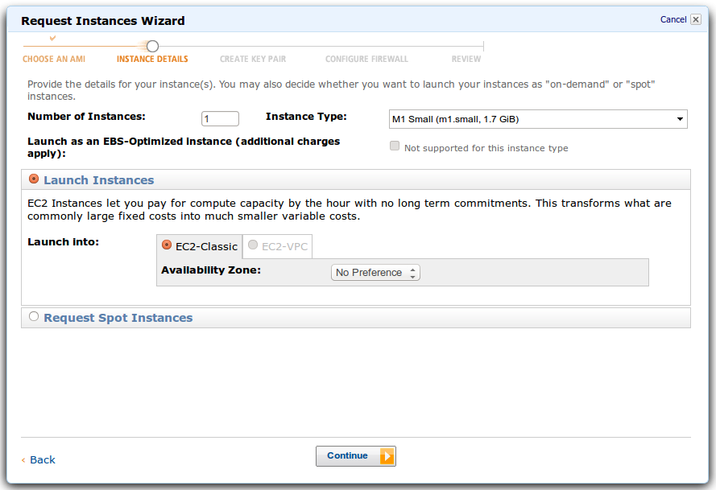
The following screen provides some more instance details. We activate Termination Protection as once an instance is terminated, all its contents are lost. This avoids costly mistakes. We leave the default options for the other fields in this example, but you may want to read about IAM Role in your deployment to better safeguard access to the instance:
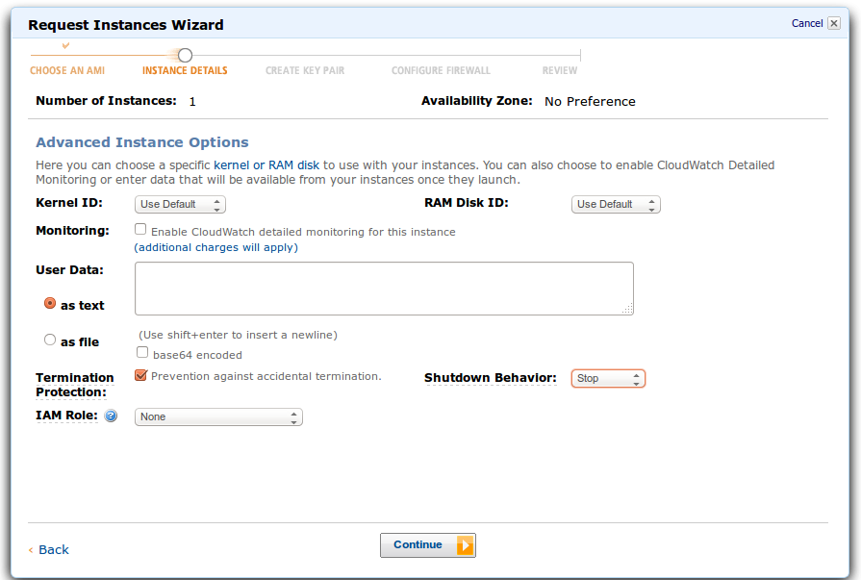
The next screen contains more instance details of which we accept the defaults:
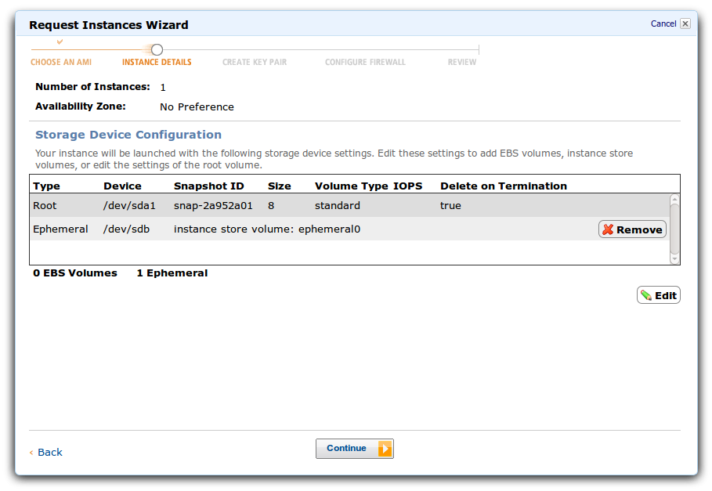
And in the following window we add a name to identify the instance:
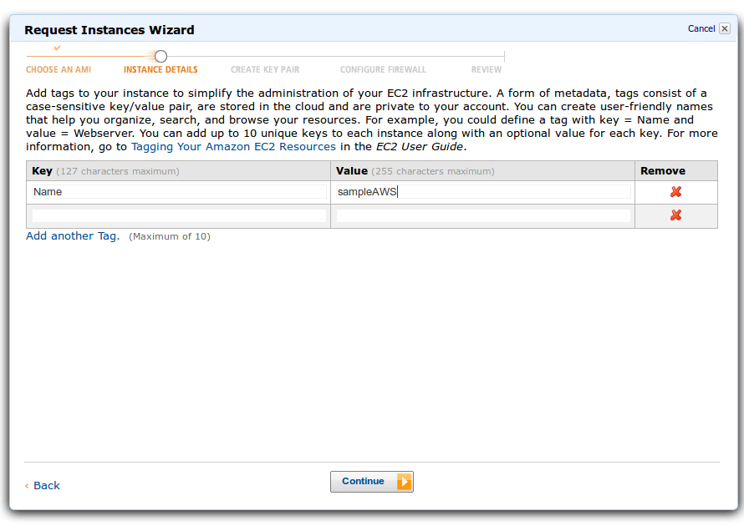
This brings us to a very important step, the creation of they key pair values. In this step we create the key pair that is used by SSH to connect to this instance. Without it, we are not able to log into it nor to execute the Ansible scripts to configure the server. If you have another Amazon key pair, you can select it as the one to use. Otherwise, as in the current example, you can create a new key pair by giving it a name and pressing Create and Download:
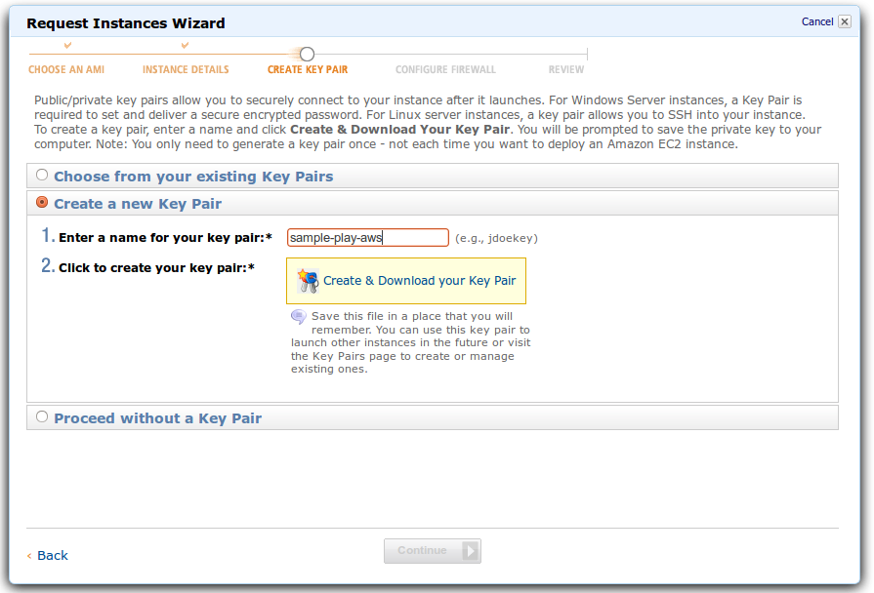
Once generated and downloaded, the wizard displays another very important screen, the firewall settings. In this screen you can select an existing security group or, as in this example, create your own. We create a new group called sample-play-aws which allows any SSH, HTTP and HTTPS connections into the machine. This way we can run Ansible scripts and connect to the server once the application is running:

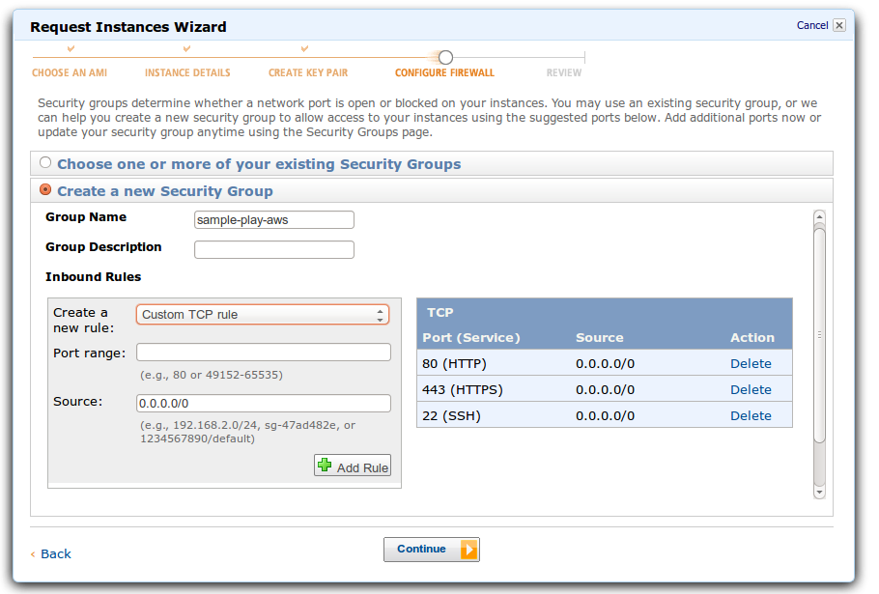
The last screen of the wizard shows a summary of the options selected and allows us to modify them before launching the instance itself:
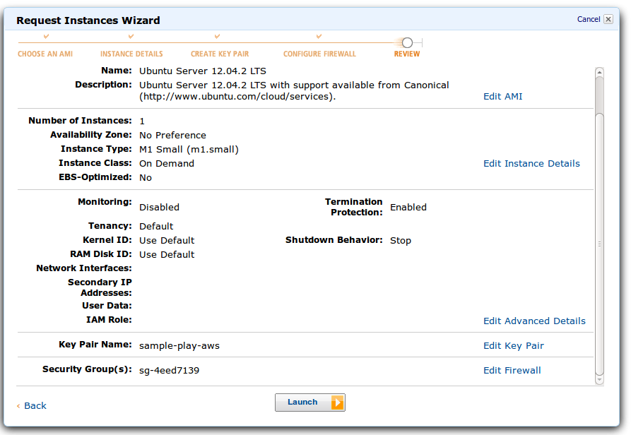
Once the instance is running you can see an entry in the console with its name, status Running and the address of the instance as shown in the following image:
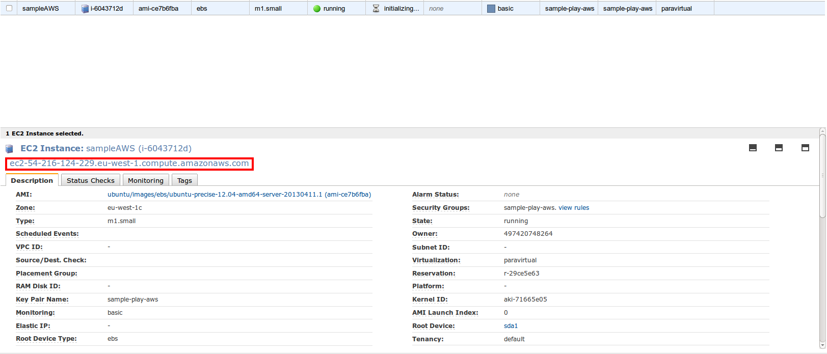
At this stage, your instance is ready to be configured using the Ansible scripts.

Execute Ansible scripts
To run the scripts you need to have Ansible installed. If you have not installed it yet, please follow the instructions corresponding to your development environment. Ansible 1.2 is required to run the scripts in this sample.
The first step to run Ansible is to copy the IP of the EC2 instance to the corresponding hosts files. In this scenario, edit testing.hosts and copy the IP under the ireland-webservers entry, as follows:
1  2  3  4  5 | # Contains the addresses of all EC2 instances used in testing in each region  # Webservers in Ireland region  [ireland-webservers]  ec2-54-216-124-229.eu-west-1.compute.amazonaws.com
You can edit production.hosts and development.hosts in a similar way if you are configuring those environments.
The next step is to set the key pair downloaded in the previous section for use in SSH. First we have to modify the attributes of the key to be read only, and then we add it to SSH via ssh-add:
$chmod 600 sample-play-aws.pem
$ssh-add sample-play-aws.pem

Ensure that all the Ansible configuration is as expected. Check the following files and update their values if needed:
- group_vars/all: set the proper configuration details, including your email and deployment paths
- roles/webtier/files/start: add the proper values to connect to the RDS db and AWS credentials via -D JVM properties
At this point we are ready to run the scripts. Go to the folder where you have deployed your Ansible files and execute the following command:
$ansible-playbook -i testing.hosts site.yml -u ubuntu --sudo
The script configures the server executing the Playbooks described above. It takes several minutes to run, and once it finishes you can access the deployed application at:
http://<amazon_ec2_ip>/
You should see the main page of the application loading on the browser.
With the server configured and the application deployed, we are ready to create the custom AMI for our environment.

Create custom AMI
Creating a custom AMI is very simple. Go back to the Amazon EC2 console and right click on the instance name. A menu to manage the instance opens:
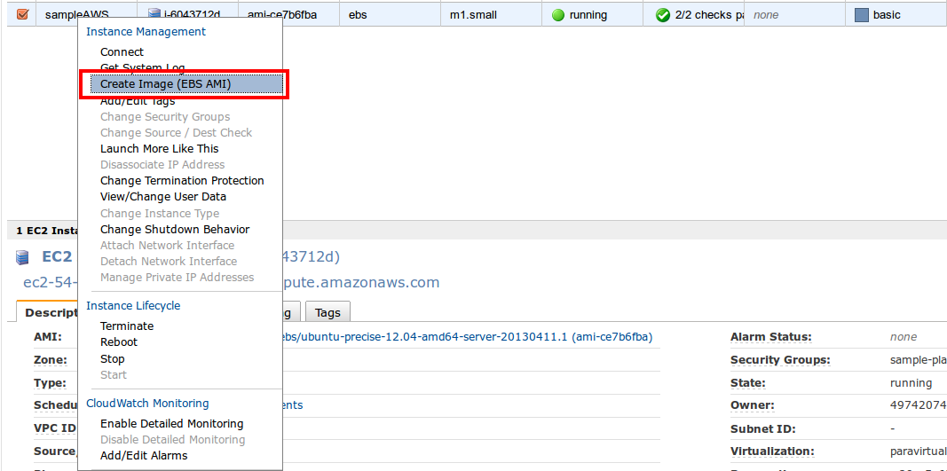
Select the Create Image (EBS AMI) option. This opens a window in which you can give a name to your AMI and select which volumes to export. In this example we export the Root volume that we have configured with Ansible:
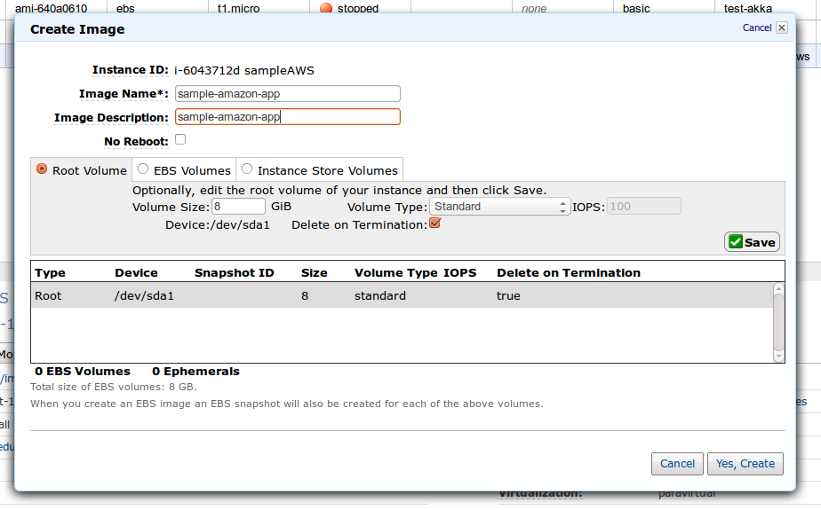
After pressing Yes, Create, AWS starts the process to create the AMI. This takes a while. You can see the AMI in the console by selecting the Images > AMIs menu:
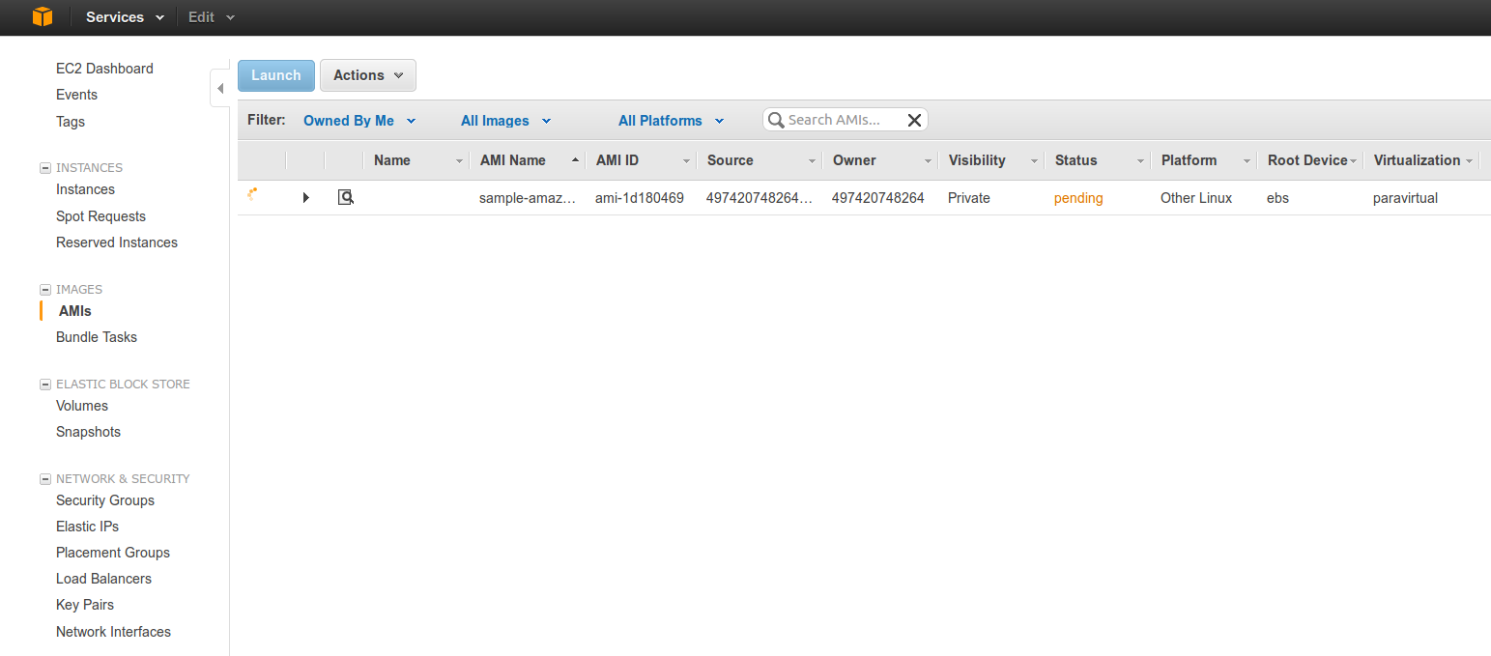
Once the creation process finishes the status will change to Complete (green) and at that moment you can use this AMI on your deployments.

Deploy other instances
As mentioned above, you can create more instances using Ansible. An alternative is to create a new instance using the custom AMI generated in the previous step. To do this, create a new instance as mentioned before, but when choosing the AMI click on the tab My AMIs. There you can see a list of your custom AMIs:
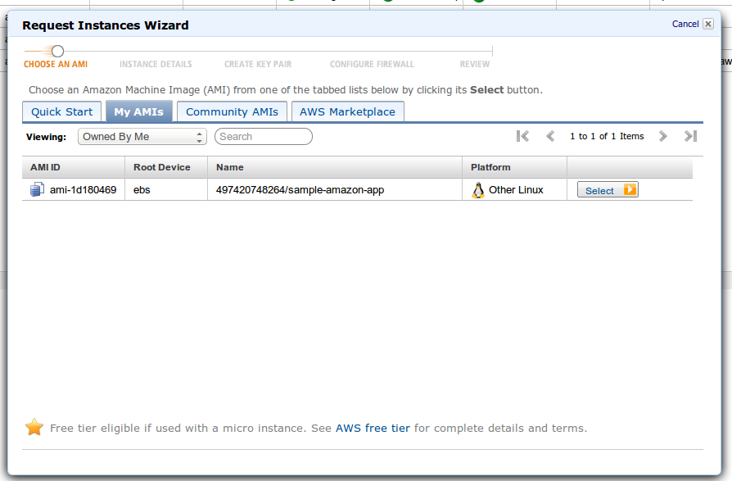
Choose the AMI you created and complete the other steps of the wizard as indicated before. Remember that this new EC2 instance already contains the server configuration and the application deployment, as specified by the Ansible scripts we executed, so there is no need to run Ansible again on this host.

Configure the Load Balancer
Amazon Elastic Load Balancing is an AWS component that distributes the load evenly along your EC2 instances. Not only that, the balancer detects the health of the associated instances and it can restart faulty instances, ensuring high availability for your application.
The Load Balancer can be created from the EC2 Console by selecting the Network & Security > Load Balancers menu:
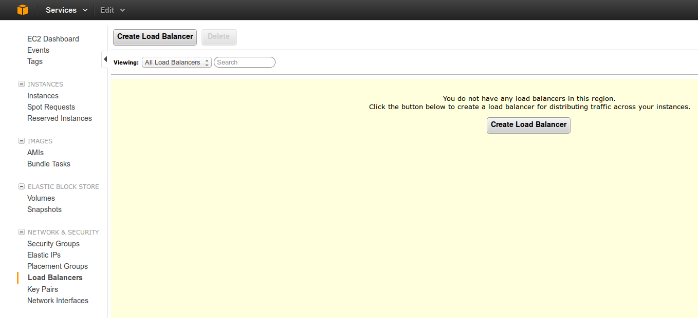
The first window of the wizard allows you to select which protocols are managed by the balancer and the mappings between the ports accessible via the internet and the internal ports accessible in your EC2 instances. In this sample, we only want to map the port 80, redirecting all the requests to the corresponding port 80 of one of our running instances:
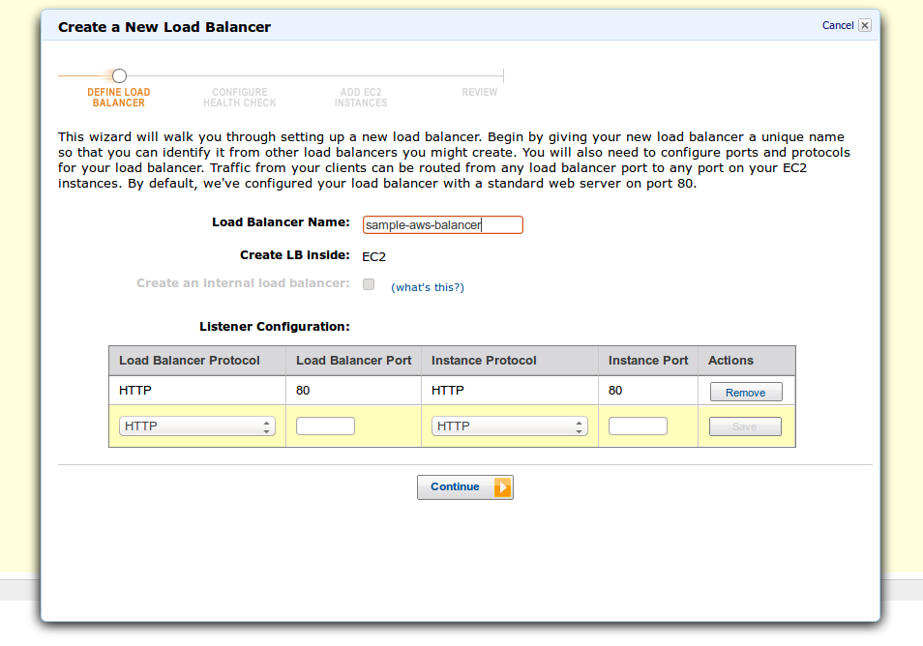
The next step sets the Health Check parameters, including which protocol, port and path has to be used for the checks and the thresholds to consider an instance as healthy or unhealthy. Unhealthy instances are automatically removed from the balancer:
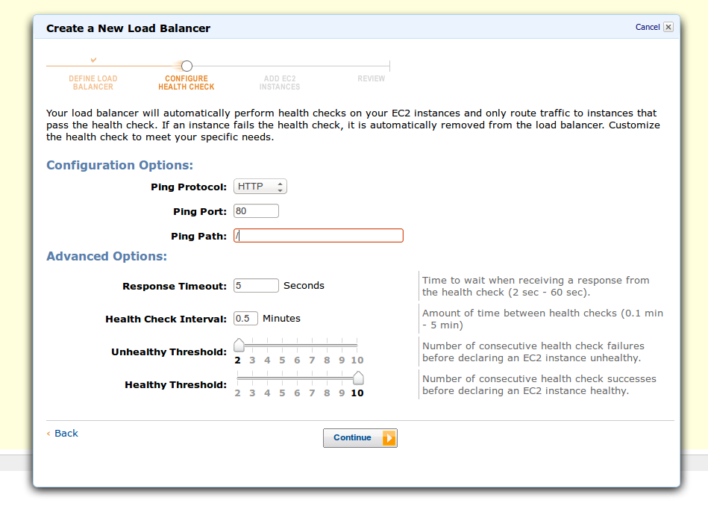
After pressing Continue, we can select the instances to be managed by the Load Balancer:
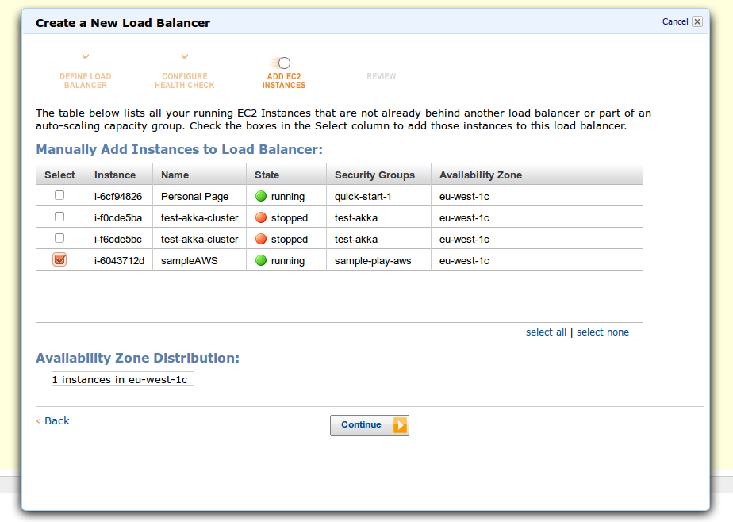
The last screen shows a summary of the values selected for the Load Balancer:
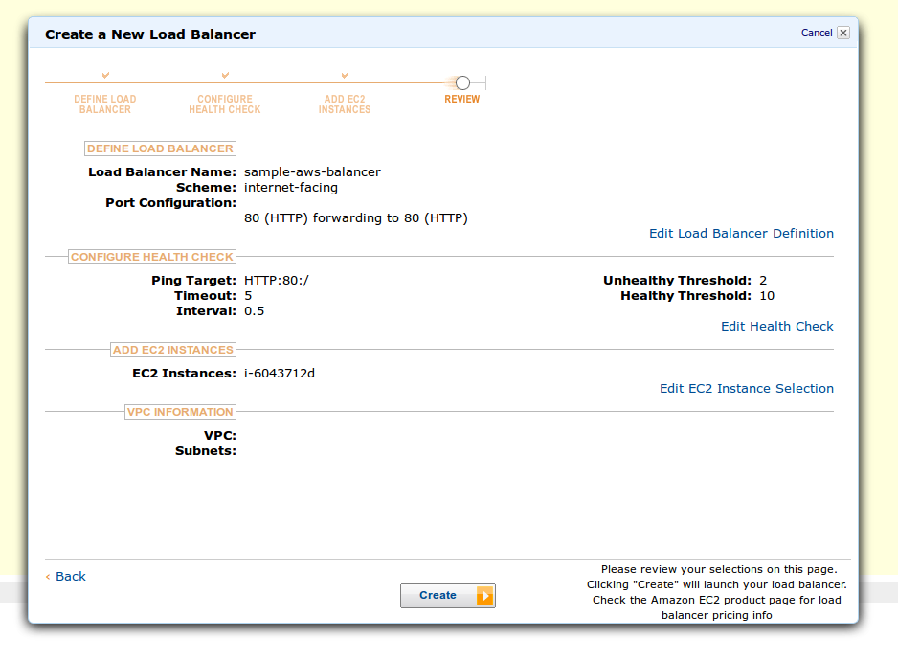
At this stage we have created a load balancer that will distribute the load evenly across our selected EC2 instances. We can manually add or remove instances to increase the capacity of our application and having total control of the costs.
Having created the Elastic Load Balancer, you can obtain its public Elastic IP. This allows you to map the balancer to a custom domain via Route 53 or your own DNS management system.

Manual creation is fine for a testing or development environment, but in production we want to create as many instances as we need, on demand, to automatically scale the application and resolve all the requests. The Elastic Load Balancer we configured doesn't allow it, but the next sections explain how to achieve this using AWS.

Autoscaling the Application
Scaling based on demand is something basic for a production environment. This gives an application the capacity to answer all the requests received, while saving money in off-peak times by stopping unused instances.
Amazon AWS allows you to define an Autoscaling Group which can be used for this purpose. Unfortunately, there is no GUI to create it. You have to download the Auto Scaling Command Line Tool and follow the instructions to install the tool in your environment. After that, a set of commands have to be executed to enable Scaling based on demand.
The following sections show the main steps in the process, but please read the Scaling based on demand instructions to have a full understanding of the steps involved.

Creating the Autoscaling Group
An Autoscaling Group facilitates autoscaling of your application by deploying new instances using a preselected AMI. To create the autoscaling group you need the id of your custom AMI. You can find it in the AMI section of the EC2 console. In this section we refer to that id as ami-id.
The first step is to create the launch configuration. A launch configuration defines the instance type to create and the AMI to use for autoscaling. If a new EC2 instance is needed, AWS reads the launch configuration and creates a new EC2 instance of the given type using the selected AMI. To create your launch configuration, execute:
$as-create-launch-config MyLaunchConfig --image-id ami-id --instance-type m1.small

The next step is to define the autoscaling group. The group defines the number of instances we want executing our application (minimum and maximum), the AWS region in which we want them and the launch configuration to use when spinning new instances. We can also link the group to an Elastic Load Balancer, to ensure that all the instances created are accessed via a common entry point. In our example we want to link the new group to the Load Balancer created previously, this way the new instances are accessible via our custom domain.
To create the group, execute:
$as-create-auto-scaling-group MyGroup --launch-configuration MyLaunchConfig --availability-zones “eu-west-1” --min-size 1 --max-size 3 –desired-capacity 2 --load-balancers sample-aws—balancer
The command indicates AWS that we create the instances in eu-west-1 and we link them to the load balancer defined in the previous section using its name as the reference (sample-aws-balancer). We notify AWS that we want between 1 and 3 instances, with a desired capacity of 2. This means that we will always have at least one instance running the application and, if the demand requires it, we can have up to three m1.small EC2 instances serving requests.

The last step is to create scaling policies that manage the resources. For example, we can create a policy that increases the capacity of our application by 30% and it is linked to the previous autoscaling group via the command:
$as-put-scaling-policy my-scaleout-policy -–auto-scaling-group MyGroup --adjustment=30 --type PercentChangeInCapacity
Each scaling policy command returns the ARN associated to the policy, for example:
arn:aws:autoscaling:eu-west-1:123456789012:scalingPolicy:ac542982-cbeb-4294-891c-a5a941dfa787:autoScalingGroupName/MyGroup:policyName/my-scaleout-policy
Keep these names as they are necessary to create the Cloudwatch alarms.

We can create a second policy to decrease the number of running instances if there is not enough traffic:
$as-put-scaling-policy my-scalein-policy –auto-scaling-group MyGroup --adjustment=-2 --type ChangeInCapacity
As you can see, several scaling policies may exist for a given group, controlling different aspects of the application. Please check the AWS documentation for more information about scaling policies.

Using Cloudwatch to Trigger Autoscaling
In the previous section, we created scaling policies that provide instructions to the Auto Scaling group about how to scale in and scale out when the specified conditions change. In this section we create two alarms, associated with the two scaling policies defined before. These alarms identify the metrics to watch and define the conditions for scaling.
The first alarm increases the size of the group if the average CPU usage is over 80% in a period of 2 minutes:
$mon-put-metric-alarm --alarm-name AddCapacity --metric-name CPUUtilization --namespace “AWS/EC2” --statistic Average --period 120 --threshold 80 --comparison-operator GreaterThanOrEqualToThreshold --dimensions “AutoScalingGroupName=MyGroup” --evaluation-periods 2 --alarm-actions <ARN_policy_scalein>
The second alarm decreases the size of the group when the average CPU usage goes below 40% in a period of 2 minutes:
$mon-put-metric-alarm --alarm-name RemoveCapacity --metric-name CPUUtilization --namespace “AWS/EC2” --statistic Average --period 120 --threshold 40 --comparison-operator LessThanOrEqualToThreshold --dimensions “AutoScalingGroupName=MyGroup” --evaluation-periods 2 –alarm-actions <ARN_policy_scaleout>
With both alarms we ensure the creation or removal of instances according to CPU usage, not wasting resources by having underutilized servers while ensuring we have capacity to fulfil the requests we receive.

You can verify your Cloudwatch alarms by running the command:
$mon-describe-alarms --headers
which returns a list of the active alarms and its associated scaling policies.
After running these steps, you have configured an automatic scaling system. This system adds new instances if the traffic increases by a certain threshold and automatically removes instances which are not being fully utilized.
Amazon AWS provides an extensive set of tools to define the autoscaling of your application. This example has shown the necessary steps to configure our sample application, but there are many other options available. Please read the documentation to know more about them.

Testing the deployment
At this stage we have deployed the application in EC2 and enabled scaling based on demand. If we access the application via the custom domain we associated to our Elastic Load Balancer, we see the main page of the application:

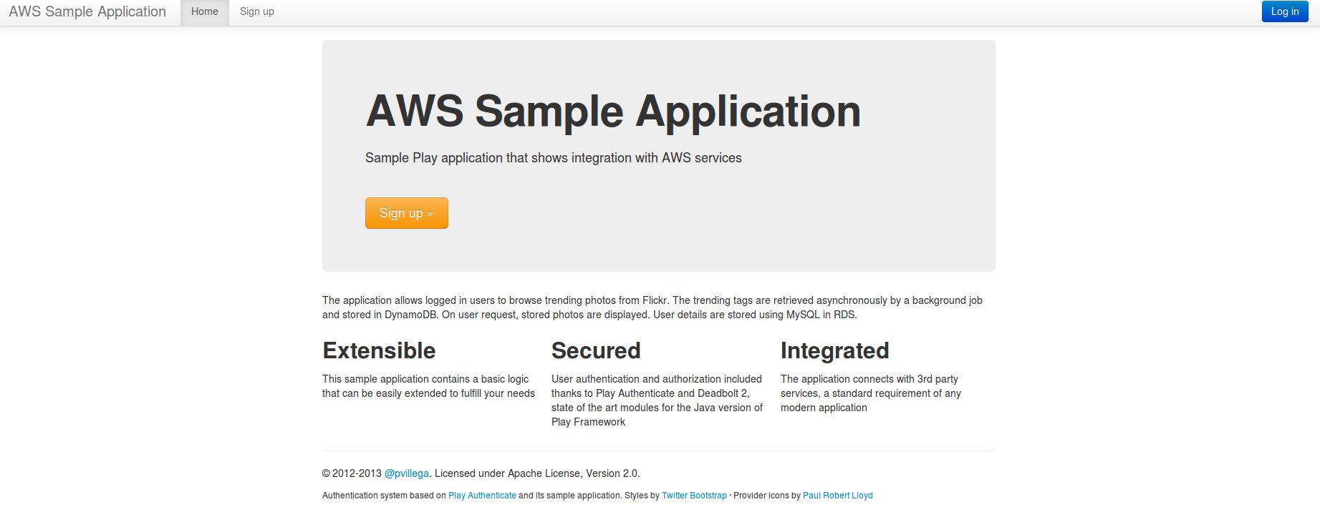
To test the scaling of the application I recommend using Siege. Usage of Siege is outside the scope of this document, but you can find an example in here.
This concludes the second chapter of the article. At this point we have created a Play Framework application that interacts with Amazon AWS and we have deployed this application in Amazon EC2 using Ansible. The next chapter explains how to deploy the same application in Elastic BeanStalk.

